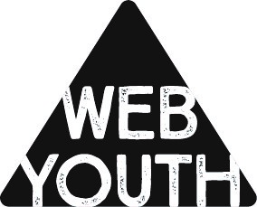

WEB YOUTH Event Participation
Parent/Guardian Consent Form

Event: Edmonton Corn Maze
Time/location: Please drop your youth off at 6PM and pick them back up at 9PM at West Edmonton Baptist Church.
Drop off/Pick up: A bus will transport us all from West Edmonton Baptist to the Maze at 26171 Secondary Hwy 627, Spruce Grove, AB
Participant(s) Name and Alberta Health Care Number(s)
1.
2.
3.

I/we, the parents of or guardians of the participant(s) named above, authorize one or more of the WEB Youth ministry staff to sign consent for medical treatment and to authorize any physician or hospital to provide medical assessment, treatment or procedures for the participant(s) named above.

I/we, undertake and agree to indemnify and hold blameless the WEB youth ministry staff, West Edmonton Baptist Church, its Pastor’s and Board of Deacons from and against any loss, damage or injury suffered by the participant as a result of being part of the activities of the West Edmonton Baptist Church as well as of any medical treatment authorized by the supervising individuals representing the church.

This consent and authorization is effective only when participating in or travelling to and from events of the West Edmonton Baptist Church.

I have read, understood and agree with the above and sign it to cover the activity listed above.

Name: Phone No.______________________

Signature:

Date:

Please retain this bottom portion for your information and return the above section.
WEB Youth Event

Event: Edmonton Corn Maze
Time/location: Please drop your youth off at 6PM and pick them back up at 9PM at West Edmonton Baptist Church.
Drop off/Pick up: A bus will transport us all from West Edmonton Baptist to the Maze at 26171 Secondary Hwy 627, Spruce Grove, AB
- Levi’s Cell 780-660-7069
- Sandy’s Cell 780-977-7320

